Aquatic Macroinvertebrate identification
Use the dichotomous key found here https://data.environment.sa.gov.au/Content/Publications/macroinvertebrate_chart.pdf to identify the Macroinvertebrates found in the images
Name of the Invertebrate | Photo of the invertebrate | Diagram of the invertebrate | Size from tip to tail | Colours | Patterns on body | How does it move? | Any other identifying features
Water boatman | 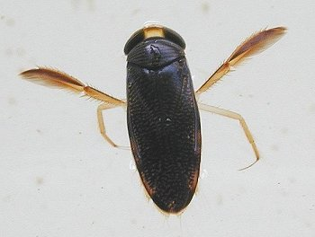
Mosquito larvae | 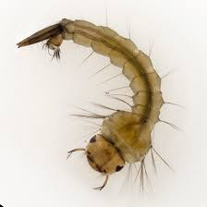
Water mite | 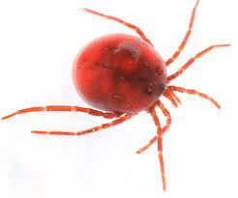
Mayfly larvae | 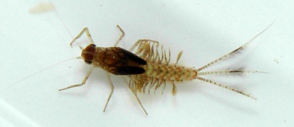
Daphnia (Water flea) | 