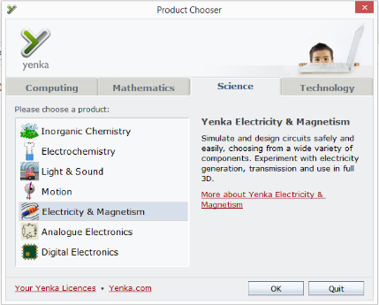
- Open Yenka
- When the ‘Product Chooser’ appears (see image on right) click on ‘Electricity and Magnetism’ the click ‘OK’
- Expand the ‘Physics’ menu by clicking on the + button beside it, the expand ‘Electricity and Magnetism’, ‘Electricity’, ‘Circuits’, ‘Series Circuits’
- Click on ‘Connection of bulbs in series’
- In the new page that appears, click on ‘(open)’
- Follow the instructions to learn how current and potential difference are distributed in series circuits.
- Use the left and right arrow buttons on the screen to navigate between pages
- Follow the instructions on the screen and complete the questions in your work books
Once you have completed the unit, click on the Yenka icon in the top left corner of the screen to take you back to the topic menu.
- Click on ‘Back to Topics’
- Choose ‘Potential difference of each component connected in series is calculated’
- Complete this unit recording the answer to each question in your work book

You need to complete all of the following units

- Relationship between the voltage and resistance in a series circuit
- Total resistance of components connected in series is calculated
- Current through each component connected in series is determines
- Relationship between the current and voltage in a series circuit

